**Hobe Sound Early Learning Center**

Chili Cook Off Entry Form

Saturday, January 18, 2025

11:00am- 3:00pm

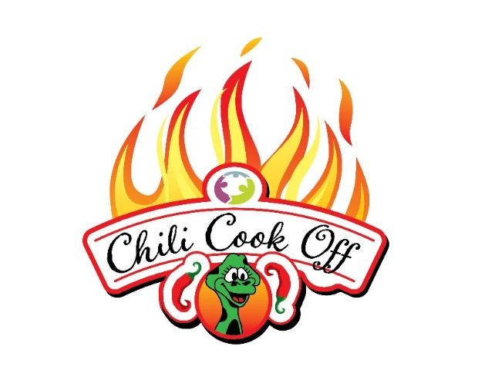

A Family FUNdraiser benefitting Hobe Sound Early Learning Center

# CAPTAIN NAME TEAM NAME

ADDRESS CITY/STATE

CASI CONTESTANT: YES__________ NO___________ OPEN CONTESTANT: YES_________ NO___________

CONTACT PHONE EMAIL

Please Make Checks Payable To: Hobe Sound Early Learning Center

Register online hobesoundearlylearningcenter.org

Please charge my credit card: Visa or Mastercard

Card #__________________________________________________Exp._________________CVV____________

Name on Card________________________________________________________________________________

Signature_____________________________________________________________________________________

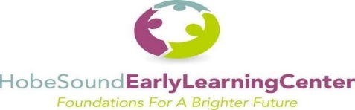

Please mail your completed form to the attention of our **Contestant Registration Chairperson** and enclose a check made payable to: **Hobe Sound Early Learning Center (HSELC)** 11580 SE Gomez Avenue, Hobe Sound, Florida 33455 | Voice: 772-546-5462 Fax: 772-546-5480 | State License #C19MA001

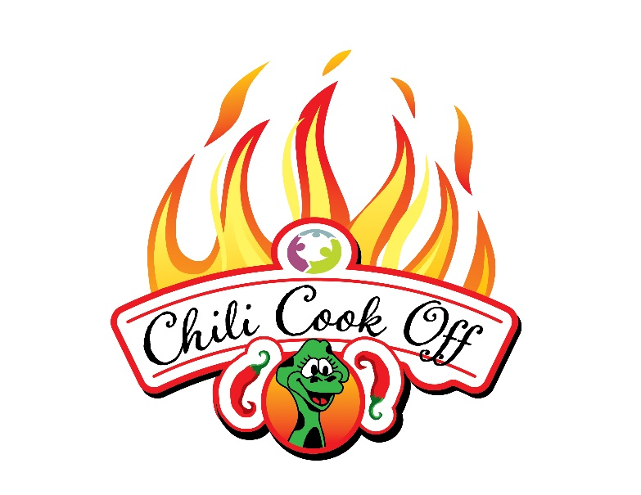

**Event Rules and Regulations**

* A team consists of a captain and up to 3 members
* Entry fee is non-refundable and due by January 8, 2025.
* Fees are $25 CASI, $25 OPEN, $15 SALSA
* Setup begins at 8:00am. CASI rules must be cooked on site. CASI turn in at 12:00pm. OPEN rules entries can be cooked ahead. OPEN turn in at 1:00pm.
* Chili contestants must bring 6 gallons of chili for samples. Salsa contestants must bring 1 gallon of salsa. Remember the more you have for samples the better chance you have to get votes.
* Each team entry must be fully self-contained. You must bring your own cooking tools, tables, tents, burners/ stoves. No electricity will be provided. Sample cups, spoons and napkins will be provided.
* Booths will be judged separately for decorations and theme by HSELC staff. There will be prizes for display/ presentation so get creative!
* People’s choice judging for OPEN rules chili and Salsa will be from 11:00am-2:30pm
* Wristbands will be sold for unlimited chili samples. Teams will check for wristbands.
* Trophies awarded at 2:30pm. CASI rules/OPEN rules/ SALSA/ BOOTH DECORATION

*Chefs will receive wristbands for tasting

