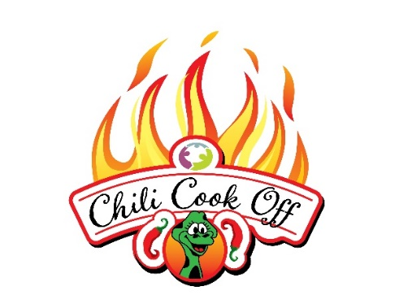

Hobe Sound Chili Cook Off Sponsorship Form

January 17, 2026

_________ Yes! I would like to sponsor the Hobe Sound Chili Cook Off

**Please Circle Level of Sponsorship**:

$5,000 Habanero Sponsor $2,500 Cayenne Sponsor $1,000 Jalapeno Sponsor

$500 Poblano Sponsor $250 Serrano Sponsors

$1,500 Kids Zone Sponsor $1,500 Entertainment Sponsor $1,500 Hospitality Sponsor

Company/Organization Name:______________________________________________________________

Contact Name:____________________________________________Phone #__________________________

Address:_______________________________________________________________________________________

City:__________________________________State:______Zip:________________________________________

Email:________________________________________________Website:______________________________

Please Make Checks Payable To:

Hobe Sound Early Learning Center

Register online hobesoundearlylearningcenter.org

Please charge my credit card: Visa or Mastercard

Card #__________________________________________________Exp._________________CVV____________

Name on Card________________________________________________________________________________

Signature_____________________________________________________________________________________