Hobe Sound Early Learning Center
Chili Cook Off Entry Form
Saturday, January 16, 2027
11:00am- 3:00pm
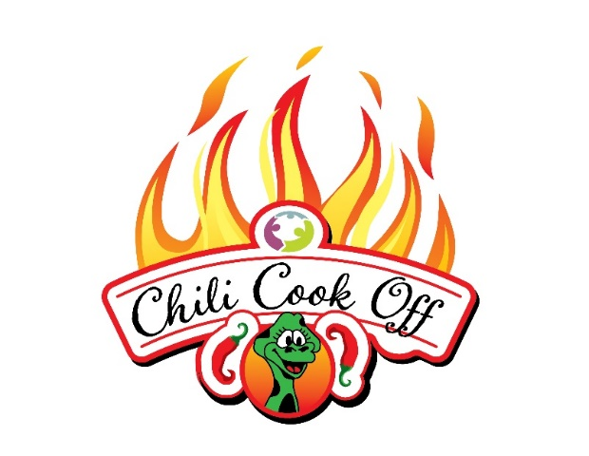
A Family FUNdraiser benefitting Hobe Sound Early Learning Center

CAPTAIN NAME TEAM NAME

ADDRESS CITY/STATE

CASI CONTESTANT: YES__________ NO___________ OPEN CONTESTANT: YES_________ NO___________

CONTACT PHONE EMAIL
Please Make Checks Payable To: Hobe Sound Early Learning Center
Register online hobesoundearlylearningcenter.org or use the QR Code below

Please charge my credit card: Visa or Mastercard

Card #__________________________________________________Exp._________________CVV____________

Name on Card________________________________________________________________________________

Signature_____________________________________________________________________________________


Please mail your completed form to the attention of our Contestant Registration Chairperson and enclose a check made payable to: Hobe Sound Early Learning Center (HSELC) 11580 SE Gomez Avenue, Hobe Sound, Florida 33455 | Voice: 772-546-5462 Fax: 772-546-5480 | State License #C19MA001

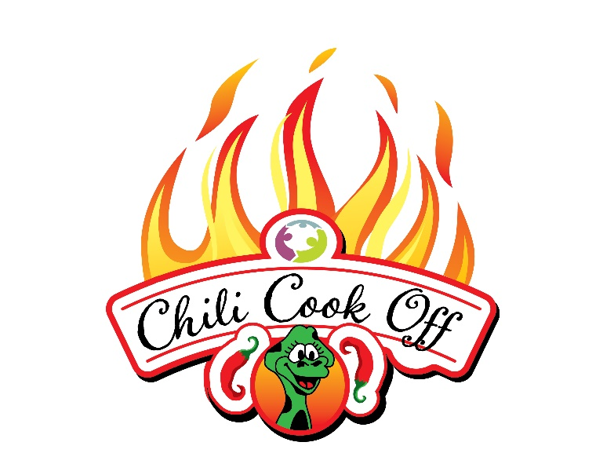
Event Rules and Regulations

- A team consists of a captain and up to 3 members
- Entry fee is non-refundable and due by January 6, 2027.
- Fees are $25 CASI, $25 OPEN, $15 SALSA
- Setup begins at 8:00am. CASI rules must be cooked on site. CASI turn in at 12:00pm. OPEN rules entries can be cooked ahead. OPEN turn in at 1:00pm.
- Chili contestants must bring 6 gallons of chili for samples. Salsa contestants must bring 1 gallon of salsa. Remember the more you have for samples the better chance you have to get votes.
- Each team entry must be fully self-contained. You must bring your own cooking tools, tables, tents, burners/ stoves. No electricity will be provided. Sample cups, spoons and napkins will be provided.
- Booths will be judged separately for decorations and theme by HSELC staff. There will be prizes for display/ presentation so get creative!
- People’s choice judging for OPEN rules chili and Salsa will be from 11:00am-2:30pm
- Wristbands will be sold for unlimited chili samples. Teams will check for wristbands.
- Trophies awarded at 2:30pm. CASI rules/OPEN rules/ SALSA/ BOOTH DECORATION
*Chefs will receive wristbands for tasting



